SRS Document

(52) – Shahid

TA Dalia Elalfy

|  |  |  |
| --- | --- | --- |
| رقم الجلوس | القسم- السكشن | الاسم |
| 20191700195 | SC - 2 | تقى عامر عبد السلام محمد |
| 20191700611 | CYS - 3 | مختار مصطفى مختار محمد |
| 20191700190 | SC - 2 | بيتر غالى حليم غالى |
| 20191700273 | SC - 2 | سارة سيد خضيرى برعي |
| 20191700274 | SC - 2 | سارة عادل الجبالى محمد |
| 20191700606 | SC - 4 | محمود محمد أحمد عمران |

1. **Introduction:**

Our Project is Shahid.net.

It’s a streaming platform which has many series and films to watch.  
It has two modes; the first is free mode which we can watch a limited number of movies and series with ads that the admin decides and the paid subscription mood that has an unlimited number of movies and series without any ads.

1. **Context Diagram:**

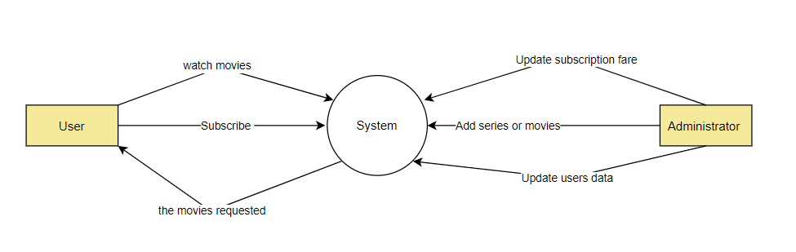

1. **User Requirements:**
   1. **As a User (Registered or Guest):**

* I want to browse the programs and series either by view them or by search for them.
* I want to watch programs and series.
* I want to view Trending page.
  1. **As a Guest:**
* I want to register to the system to have an account.
  1. **As a Registered user (Subscribed or Unsubscribed):**
* I want to login into the system to access my account.
* I want to edit my profile data.
* I want to rate programs that I watch to give my feedback.
* I want to add content to watch later list.
  1. **As a Subscribed user:**
* I want to switch safe mood on, and system requires the user’s password to turn it off.
* I want save content offline.
* I want to renew subscription monthly to keep watching special content.
  1. **As an unsubscribed user:**
* I want to subscribe to the system to watch special content and have more features.
  1. **As a Production company:**
* I want to send programs and series to the system.
  1. **As an Admin to system:**
* I want to manage programs and series so I can edit, add, and delete them.
  1. **As a Time actor:**
* I want to manage the periods that the adds appear and the duration of each one.
* I want to manage the subscription date of each user.

1. **Functional Requirement:**
   1. **Register:**
      * Guest users shall be able to register to the system.
      * Inputs: Full name, Username, Password, Email, Year of birth.
      * Input fields.
      * User must be guest user.
      * The user type is changed from guest to (Registered) Unsubscribed user.
      * System shall display massage to user that contains “Congratulation you registered to the system successfully”.
   2. **Watch later:**
      * Registered (subscribed or unsubscribed) users shall be able to choose items and add them to watch later list.
      * Click on watch later button for the item.
      * Watch later button.
      * User must be registered user.
      * Item is added to watch later list.
      * Watch later button changes its color to yellow.
   3. **Save offline:**
      * Subscribed users shall be able to add items in offline list and can watch them in offline mode.
      * Click on offline button for the item.
      * Offline button.
      * User must be subscribed.
      * Item is added to offline list.
      * System shall display massage to user that contain

“Item is added to offline list successfully”.

* 1. **Login:**
     + Registered users (subscribed or unsubscribed) shall be able to login to the system.
     + Inputs: username, password.
     + User must be registered or subscribed.
     + Increment variable online_Users by 1.
     + The Screen shall display the user’s home page.
  2. **Send Programs:**
     + Production companies’ user shall be able to send series and programs to the system.
     + Series and programs.
     + Data base connection between the two systems.
     + User must be Production company user.
     + Items are added to the system database.
     + System shall display massage that contains

“Items are added to system successfully”.

1. **Non-Functional Requirements:**
   * System takes 0.5 sec in response time.
   * System needs 40 MB to install on hard desk.
   * System takes between 1 and 1.5 sec to restart after failure.
   * System is developing as windows form application.
   * Programming language that is used is C#.
   * System needs visual studio IDE as a tool for developing it.
   * System needs oracle server database.
   * I/O devices that system need are mouse and keyboard.